Gooseberry Kitchen

Picture of website could go here
Include the link to your deployed website

Connor Vogelaar, Hubert Zieba & Roisin Kelly
09-11-2025

Table of Contents
1. Executive Summary 1
2. Project Work 1
3. Design Process 1
4. Testing & Responsiveness 1
5. Conclusion 1
6. References 3

Executive Summary
We chose this project as one of our team members has a girlfriend the is starting a catering business called Gooseberry Kitchen. This is a topic where we can avail of information from Gooseberry Kitchen including images provided by them. This allows Gooseberry Kitchen to advertise their menu. Allow people to contact them and find out more about the company.

Please use Harvard referencing if pulling material from the web about your chosen company or for any other material that you used in your document and you did create yourself. Sample reference: "according to (Finance, 2015) there is a good idea to learn how to properly reference sources". NCI referencing guide - https://libguides.ncirl.ie/referencingandavoidingplagiarism/harvard. Put in here using the references tab here in Word or your own referencing manager software, e.g., Mendeley, Zotero, CiteThemRight, etc.

Also, pop in the link to your deployed website.

Project Work
The project team split the work into 4 sections, individual responsibility and shared responsibility as follows:
 | HTML | CSS | JavaScript | Other
Connor Vogelaar | Menu.html | Connorstylesheet.css |  | Point of contact for Gooseberry Kitchen
Hubert Zieba | About.html  Index.html | Hubertstylesheet.css
Roisin Kelly | Contact.html | roisinstylesheet.css | Contact.js
Shared |  | Style.css | Script.js | Report Document,

Design Process
Colour palette, fonts used, buttons used etc. Lots of images and reasons why certain things were done the way they are presented on your website. Show wireframes for each web page and reference at least one design pattern per wireframe.

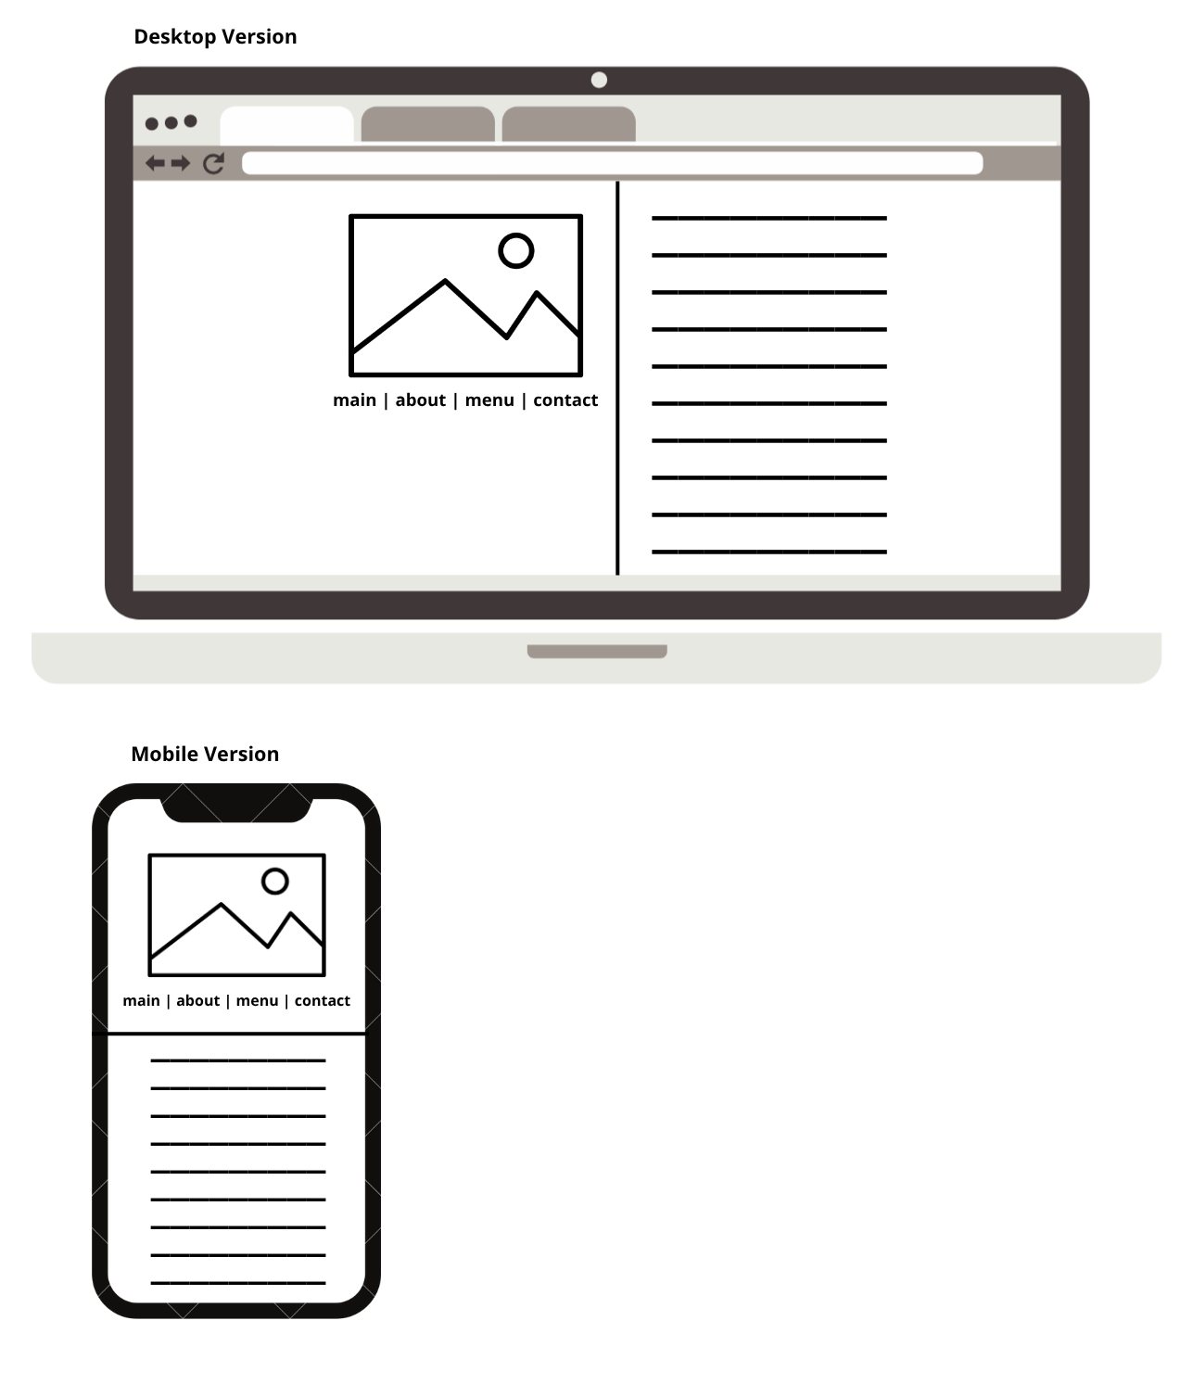

Testing & Responsiveness
Talk about website responsiveness here along with Optimisation, SEO and Testing. You can talk about how you made your website responsive. You could also mention how you used JavaScript: loops, if statements, etc. How you deployed your website?

Conclusion
Overview of how the project went, did you work together well as a team? What was difficult to do, how you feel the website looks and if you had time, would you make any changes?

References
Finance, B. &., 2015. Flexible working worth €2.5bn to Irish economy. [Online]
Available at: http://businessandfinance.com/news/flexible-working-worth-e2-5bn-to-irish-economy/
[Accessed 8 March 2023].

